Reflection
Tales from the Classroom
What Worked Well….. WWW
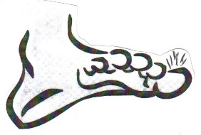 The Hairy Toe
My Favourite Moment so Far (after lessons 1 and 2)
Some thoughts. Fourth Class. Jan 8th 2026
- When we did the freeze frames yesterday
- Statues
- When we had an audience
- A living picture
- When we were acting
- When we made the map
- Yesterday when we were making a show
- When the Monster lost his big toe
- When we drew the map of the granny’s house, beanfield, mountain range and forest
- When I was pointing at my blue toes
- The Monster. It was funny.
- I was interviewed by my friends
- When the Drama teacher told us the story
- We practised for statue images
Even Better if….
- I was doing the laundry or washing the dishes
- We could do a mini show
- We play mood games like you walk around the room. You call out a mood and you walk in that mood.
- If people weren’t talking when other people are performing
- If we knew where we had to go and if we listened to each other more.
- We had more time to practise
- Everyone listened when other people are acting
- We could do a mini-drama
- Do a bit more acting
- We could have more characters

