Cork Drama Meitheal
13th January 2026
Cork Education Support Centre
”The Hairy Toe” 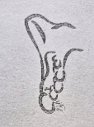
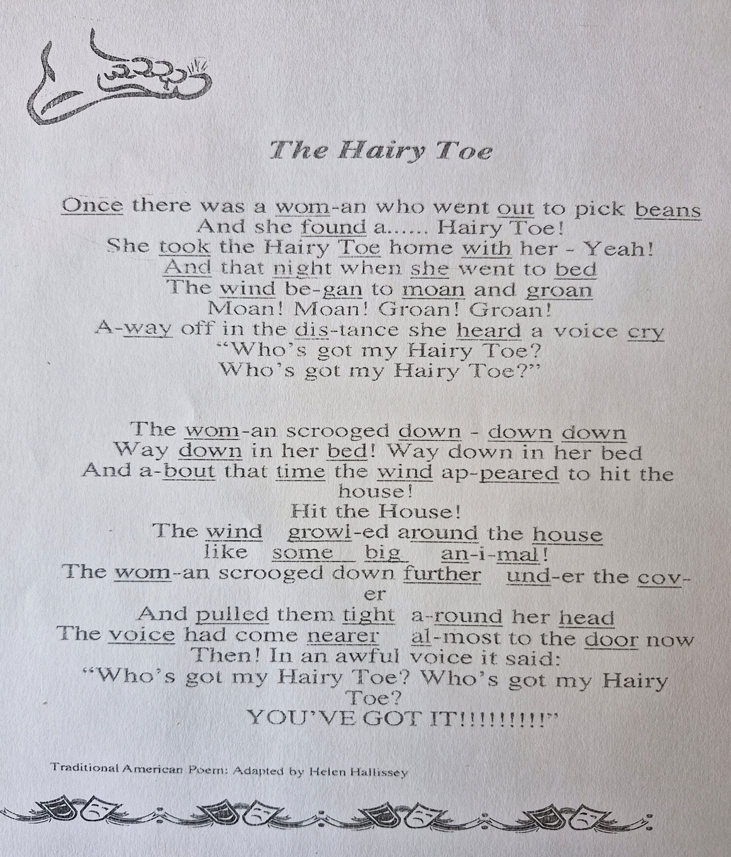
A Basic Drama Lesson Scheme by Helen Hallissey
Safe Learning Environment
- Warm up. ‘Stop’ signals. De-rolling chant and Drama Contract

Strand 1 - Creating
Teacher teaches Verse 1 of the poem ‘The Hairy Toe’

Step 1: Defining the Space
- Mapping or using furniture and objects

- Soundscape of the night (voice or instruments)

Step 2: Meeting the Characters

- Still Image: groups of three (monster, woman, child)

- Ritual (three moves – mechanical)

- Thought Tracking of the characters

Step 3: The Story
- A Day in the Life. We will trace the steps of the story: morning, afternoon, night
(Flashback to the morning etc)

- Carousel the three moments (share ritualistically)

Strand 2 – Performing

Step 1: Making the Film. Groups find outdoor locations and film the Day in a Life

Step 2: Interviews at Headquarters
- Defining the space / rearrange the furniture. Paper Location. Soundscape

- Hot-seating the Monster / Set up by preparing 3 questions. Teacher in role

- Students in role as investigators interview the Monster. How they stand / sit?

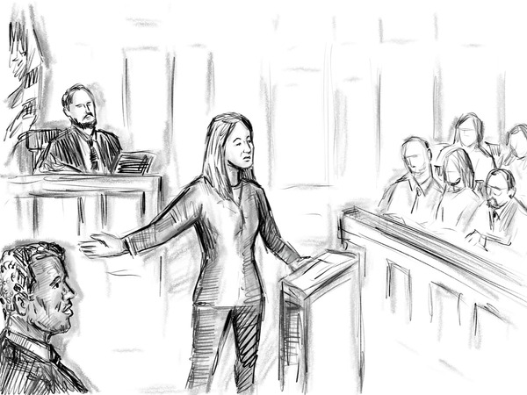

Step 3. In the Courtroom
- Defining the Space. Soundscape
- Roles.
- Vocabulary. Conventions of the court.
- Verdict. Paparazzi

